*And The Big Men Fly*

By Alan Hopgood

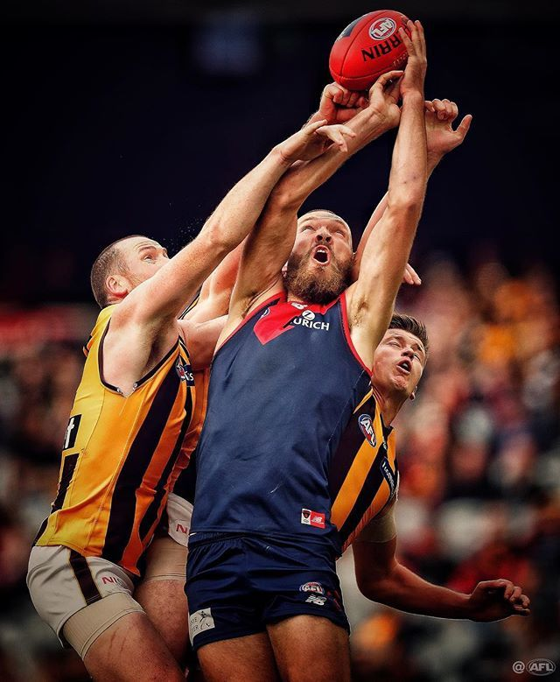

The Following is an excerpt from ‘Lunch with Alan Hopgood’ written in 2013 about the play ‘And the Big Men Fly’.

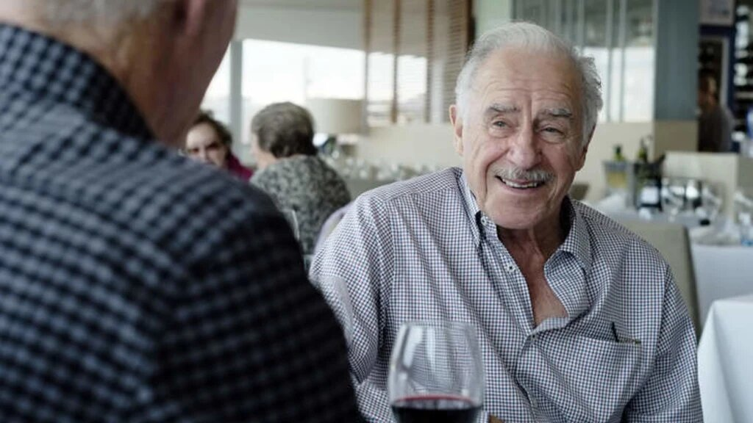

 It is the 50th anniversary of his iconic play, *And the Big Men Fly*, as big an Aussie rules landmark in theatre-land as Mike Brady's *Up There Cazaly* is in song. It was in 1963 that Melbourne Theatre Company boss John Sumner, who died in May, came to Hopgood for help. The play *The Man Who Came to Dinner*, which starred Frank Thring and which was expected to run for months at the Russell Street Theatre, had bombed unexpectedly and they needed a replacement urgently.

'You write plays, don't you boy?" Sumner asked Hopgood, who was in the cast. "Have you got anything?" Hopgood confirmed that he had - but needed a week. There was a good reason for the delay - he had the idea but had not written the play. Seven days later, Hopgood presented Sumner with his new work and it was staged to acclaim from audiences and critics.

''It educated my two kids,'' Hopgood says. ''It was made into a TV mini-series and almost 250,000 copies of the script have been sold since.'' He had plans to stage it again in this anniversary year but feels recent productions of *Barassi* and *The Club* have drained the pool as far as footy-flavoured theatre goes. ''We might have a sort of celebratory reading,'' he says, ''and if that works we could start touring it next year.''

**ANALYSING DRAMATIC TECHNIQUES IN A PLAY**

1. **Introduction**

A play, in a way, is a game which creates and imagine of life. The playwright persuades us to step into a make believe world, to pretend that characters are real-life people, that fictional events matter. Interest is created by having a little of the story revealed at a time; manipulating language and the symbols of actors, props and sets; alternatively revealing and concealing events and their explanation; creating suspense and then releasing us from it. We need to pick up clues so that characters come into focus, and so that events become patterns evolving into a theme.

1. **THEME:** A play focuses on particular events. The events have meaning extending beyond the play: this meaning is the play’s theme. It is the point of the play. It should tell us something about human nature and existence and how behaviour and patterns threaten social concord.

In a well written play, plot, character, dialogue and setting all contribute to theme. We must add up the clues and work out for ourselves what the point of the play is.

1. **PLOT:** Plot is a sequence of events with a cause and effect connection.
2. **EXPOSITION:** Often a play begins in middle of a sequence of events and the opening will convey much information, especially the dialogue. Consider how the exposition:

* Establishes setting – time and place
* Introduces characters
* Introduces relationships
* Conveys physical background
* Give information for the plot to proceed
* Sets up atmosphere, mood, tone
* Sets up a situation form which suspense arises.

The overall action of a conventional play has two parts: the dramatic question, posed early in the play, and the action which is developed and the finishes with the resolution. Complications hinder the immediate answering of the dramatic question, and provide plot and character interest. In other words the essential component is the CONFLICTS **o**f the play and their resolution. These conflicts may be between people, within individuals, or between characters and forces around them. When a characters faces conflict he becomes more complex and dramatically interesting. Conflict creates the tensions of the play, as we wait to see whether the characters can overcome the forces opposing them. Conflict draws on the characters’ resources, and, as they move to resolve the conflict, much is revealed about them. It is the dialogue, the movement and the relations between the characters which demonstrate conflict.

1. **CHARACTERS:** In most plays the main character is someone trying to achieve something, work out something, or solve some problem. The characters are usually caught up in some sort of crisis, dilemma or confusion (conflict). These are the forces which drive them on.
   1. **Consider:**

* Their movements and gestures – the way they do things and the reason for doing them.
* Their dialogue, what they say and how they say it. This is carefully composed to fill a purpose.
* The imagery and symbolism – of language and props.
* Setting – what does it contribute to the characters? Are they at odds with it? Do they create it or is it forced upon them?
* Their interaction with other characters and what other characters say about them.

1. **STAGE DIRECTIONS** – often give us an insight into the motives which drive the characters and the action of the play.

In a play every physical detail, including music and sound effects, is a significant clue to the personalities of the characters and to the theme. PROPS are also significant in the same way and can become symbolic. Consider sound effects, music, lighting, movements and costumes. Look for contrasts.

1. **DIALOGUE**: A playwright can’t guide our response to characters; he must let the characters speak for themselves. The dialogue must convey thoughts, motives, feelings, attitudes, fears and desires. Even silences and hesitations become very important. Dialogue is not random talk, as in real life, it is carefully structured to fulfil a purpose. How the dialogue is spoken is of great importance. Speech patterns and imagery are particularly revealing, as is choice of diction.
   1. **Consider:**

* Words and sentence structure
* Language – formal, informal, colloquial
* Figurative or literal language, rhetorical or lyrical
* Subjective or objective
* Tone, pace, rhythm, repetition, volume
* Irony, sarcasm, humour, paradoxes, clichés
* Description, arguments, preaching, persuading, philosophy, narrating, explaining, satire

1. **SETTING**: The setting helps to convey the themes of the play, whether it is symbolic or a replica of the real world. The setting also makes visual comments on the characters and it helps convey the atmosphere.
2. **TECHNICAL CONSTRUCTION**:

* Exposition/Introduction
* Rising and falling action, complications
* Division into scenes and acts
* Climax
* Turning point
* Denouement (resolution of plot, conclusion)
* Special Devices – like use of a chorus (as in Medea), narrator, asides, soliloques, flashbacks, singing etc.

# *And the big men fly*

# Alan Hopgood

Act One

1. Read Act One of the play ‘And the Big Men Fly’
2. In the below table fill in any details that you can identify about the main characters.

(Include any full names, where they live, their profession and any idiosyncratic (i.e. quirky) behaviour.)

|  |  |
| --- | --- |
| Achilles Jones |  |
| Lil |  |
| J.J Forbes |  |
| Wally Sloss |  |
| Harry Head |  |
| Wobbly Coats |  |

1. In point form summarize what has happened in the play so far.
2. ‘What’s the matter? I can read real beaut, if I take me time.’ Is a quote from page 9, what does it tell us about the character?
3. Read Pages 12 and 13 again. What do these pages show us about how Wally and J.J. view the world? Is the author exaggerating the characters on purpose?

# *And the big men fly*

# Alan Hopgood

Act Two

1. Read Act Two of the play ‘And the Big Men Fly’
2. In the following table write down any extra information you know about the characters after reading Act 2

|  |  |
| --- | --- |
| Achilles Jones |  |
| Lil |  |
| J.J Forbes |  |
| Wally Sloss |  |
| Harry Head |  |
| Wobbly Coats |  |

1. Write a summary of the second act.
2. How does the language in Act Two contribute to the meaning of the play? How has the author use speech to develop the characters? Give specific examples.
3. What can we learn about Australian society from Act Two of the play?

**Character Analysis – ‘Who am I?’**

Choose **ONE** Character from ‘And the Big Men Fly’ and complete the Character Analysis below:

Title of Play: ________________________________________________

My character’s name: _________________________________________

**Physical Traits and Appearance:**

External aspects:

My age is: __________

What do I look like? (Be as accurate as possible). __________________

_________________________________________________________________________________________________________________________________________________________________________________

(For example – physical shape, posture, grooming habits, hairstyle, makeup. Examples of posture would include descriptions such as ‘slumping’, ‘stiff’, ‘relaxed’, ‘timid’, ‘graceful’, ‘assured’ or ‘awkward’).

Do I have any specific type of movements or gestures? _____________

______________________________________________________________________________________________________________________

(Examples would be walking with a stride, plod, shuffle, bounce. Does the movement and/or the gestures convey poise, nervousness, weakness, strength? How does he movement indicate age, health and/or attitude?

Do I have any mannerisms or handicaps? _________________________

______________________________________________________________________________________________________________________

(Mannerisms: these are also called ‘leading gestures’ or a movement that your character unconsciously uses throughout the play. Examples could be nail biting, playing with your hair, clearing throat, keeping hands in pockets, chewing gum, scratching head, doodling on paper, picking lint from clothes).

What do I wear? _____________________________________________

______________________________________________________________________________________________________________________

(Dress habits, clothing. Examples would be neat, casual, sloppy, prim, clean, dirty, clothes in good taste, fashionable, well-groomed, traditional, non-conformist).

What are my speech patterns and voice type? _____________________

___________________________________________________________

(Examples would be regional or ethnic accent, a twang, a drawl, high-pitched, deep, slow, fast).

**Atmosphere:**

Where am I living? ___________________________________________

(Country, state, community, rural, suburban, city, inner city).

What is the play’s period or time? _______________________________

What is the time of year? (Season/weather). ______________________

What is the time of day? ______________________________________

Where is my favourite place in the setting? _______________________

**Character’s Background:**

What is my life story? What is my history? How does my past shape my present? My temperament is? List at least 6 adjectives that specifically describe my emotional traits, complexes neuroses, obsessions and superstitions.

1. _______________________
2. _______________________
3. _______________________
4. _______________________
5. _______________________
6. _______________________

(Some examples would be: confident, outgoing, happy, poised, sullen, confused, nervous, cynical, timid, hot-tempered, bored, blasé, antagonistic, addled, slow-witted, submissive, fearful, arrogant, vain, rude, meticulous, lazy, egotistical, smug, polite, careless, introverted, extroverted).

How much education have I had? _______________________________

Favourite or hated subjects studied? _____________________________

What are my mental characteristics? _____________________________

___________________________________________________________

(For example – intelligent, clever, dull, slow, average).

What is my marital status? ____________________________________

What is my ethnic background? _________________________________

What is my occupation/profession/job? ___________________________

Are you happy with your work? Why? ____________________________

___________________________________________________________

What are my interests, hobbies and amusements? Why? ____________

___________________________________________________________

**My family background and family life:**

Is my family rich, poor or middle class? __________________________

Where did I grow up? What do I remember about the neighbourhood? _________________________________________________________________________________________________________________________________________________________________________________

What were the circumstances of my growing up? __________________

______________________________________________________________________________________________________________________

How do they influence or act upon me today? What is my favourite childhood memory? What is my worst childhood memory? What is my relationship with my family? ___________________________________

__________________________________________________________________________________________________________________________________________________________________________________________________________________________________________________________________________________________________________________________________________________________________

What siblings do I have? ______________________________________

What role does it play in my everyday life? ________________________

______________________________________________________________________________________________________________________

What are my ethics? (Morals, beliefs, ideals, ethical code). ___________

______________________________________________________________________________________________________________________

What is my political position? __________________________________

What is my social position? ____________________________________

'What is my status: in the world, family, relationships? ______________

______________________________________________________________________________________________________________________

**Always make specific choices:**

**Relationships:**

What is my relationship/feelings (emotional and psychological) to each of the other characters I have contact with? This might include briefly describing your relationship to the other characters. This could include ‘status’ relationships.

|  |  |
| --- | --- |
| **Character’s name** | **Feelings towards character** |
|  |  |
|  |  |
|  |  |
|  |  |
|  |  |
|  |  |
|  |  |
|  |  |
|  |  |

Who do I like least in the play? Why? ____________________________

______________________________________________________________________________________________________________________

**Additional Questions:** (The following questions are not applicable to every character).

Do I have animal characteristics? _______________________________

If so, which animal? __________________________________________

What rhythm do I associate with my character? ____________________ (For example – the steady swing of a pendulum).

What personal sound do I associate with my character? Why? ________

______________________________________________________________________________________________________________________(For example – sighing, wheezing, grunting).

What object do I associate with my character? ____________________

My favourite food, meal, drink, restaurants are… ___________________

___________________________________________________________

Homemade foods I ate as a child? ______________________________

My favourite music is? Why? ___________________________________

My favourite colour is? Why? ___________________________________

The colour I associate with my character is? Why? _________________

___________________________________________________________

What is my favourite time of day? Why? __________________________

___________________________________________________________

What is my favourite season? Why? _____________________________

___________________________________________________________

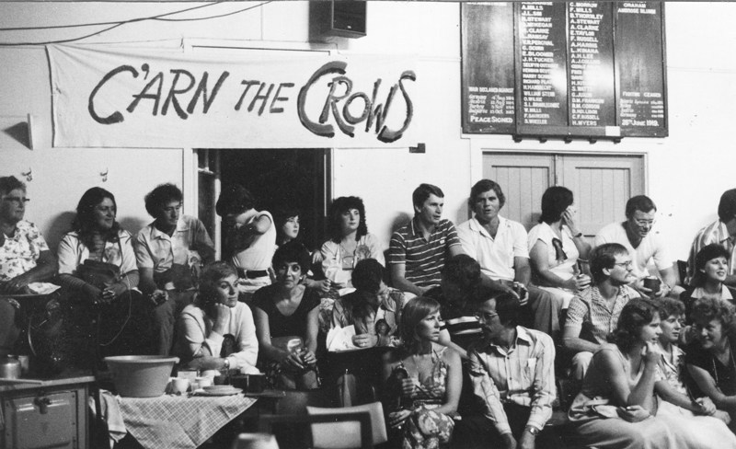

# *And the big men fly*

# Alan Hopgood

Act Three

1. Read Act Three of the play ‘And the Big Men Fly’
2. In the following table write down any extra information you know about the characters after reading Act Three.

|  |  |
| --- | --- |
| Achilles Jones |  |
| Lil |  |
| J.J Forbes |  |
| Wally Sloss |  |
| Harry Head |  |
| Wobbly Coats |  |

1. How is the ending significant to **ONE** character’s development within the play?
2. What does the ending revel about the Achilles Jones?
3. In your own words describe why on Page 87 Les says ‘I ain’t had no real proof that Acky can play footy.’
4. Choose a quote for **ONE** character that you see as the most important for that character. Discuss why you chose this quote.

**Revision Questions**

Each question should take you at least half a page to a page to answer.

1. What are the play’s main themes?
2. What is each character like and what are their values and attitudes?
3. What representation of Australia and Australians is presented in this text? Does this representation match your own image of Australia and Australians?
4. Identify uniquely Australian language used in the play. Is it still used today? Discuss.
5. How do plays differ from other narratives such as short stories and novels? Give examples from the play.
6. Complete a close reading of one section of the play.